# MIST352- Homework 2 - Building a Simple Business Application (100 points)

## Objectives:

The goal of this homework is to develop a simple business application using Java. This application will demonstrate your understanding of basic Java programming concepts, including if statements, switch statements, and the use of `JOptionPane` for input and output. This assignment will focus on creating a user-friendly interface for a fictional small business, "Java Juice Bar," where users can select services and get calculated costs based on their choices. You may search the web for specific java questions such as how to accept integer using JOptionPane, or how to use JOptionPane.showConfirmDialog(…) however, you are not allowed to use ChatGPT. You are not allowed to use any services such as chegg.

## Business Context:

"Java Juice Bar" offers customers a variety of fresh juice options and add-ons. Customers can choose a base juice and add optional extras for an additional cost. Your program will help the cashier input customer choices and calculate the total cost.

Deliverables:

Submit a java project named HW2 under the Homerowks folder of yoiur repository. Push your code to GitHub and submit a notice on eCampus sating you pushed your code. Please verify yoiur code is on GitHub by navigating to GitHub and checking for your project. If your project has any syntax errors, an immediate 50% penalty will be applied.

## Requirements:

1. User Input with JOptionPane: Use `JOptionPane` to show dialog boxes for user inputs and outputs throughout the application.
2. Switch Statement for Selections: Implement a switch statement to handle different juice base options.
3. If Statements with Logical Operators (AND, OR): Use if statements with logical operators to apply discounts or additional charges based on the customer's selections.
4. String.format for Output: Use `String.format` to format the final bill that includes the customer's selections and the total cost.

## Instructions:

1. Create a Java Project named HW2 under the Homework folder of your repository. **[10 points]**
   1. Create a java class named HW2
      1. Add a commented box of:
         1. Your First and Last name as shown on eCampus
         2. HW2-[Date]
2. Your program should start by Displaying a Welcome Message: Use `JOptionPane.showMessageDialog` to display a welcome message to the user as shown in Figure 1. **[10 points]**

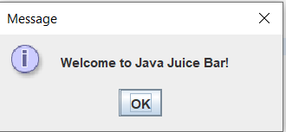

Figure : Welcome message

1. Ask the User for the Base Juice Selection: Display a dialog box using `JOptionPane.showInputDialog` asking the user to select a base juice by entering a number as show in Figure 2. **[10 points]**

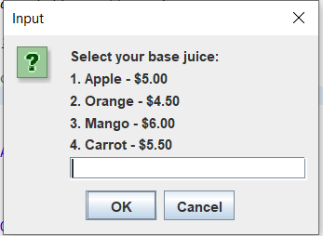

1

Figure : Options of the juice bar

1. Implement a Switch Statement: Based on the user's selection, use a switch statement to set the price for the chosen base juice. **[20 points]**
2. Ask for Add-Ons: Ask the user if they want to add any extras( see Figure 3 ) . Use the JOptionaPane.showConfirmDialog(…) to the Yes/No part. Use if statements with logical operators to handle these choices and adjust the total cost accordingly. **[20 points]**

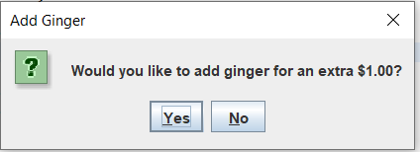

Figure : Adding extra option

1. Apply a Discount: If the user chooses Mango as the base juice and adds ginger, apply a $0.50 discount to the total cost. Use an if statement with AND operator to implement this.**[10 points]**
2. Format and Display the Final Bill: Use `String.format` to create a formatted string that summarizes the user's choices and displays the total cost. Show this information using `JOptionPane.showMessageDialog` as shown in Figure 4. **[15 points]**

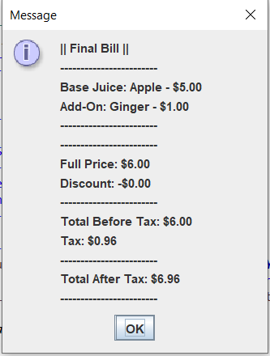

Figure : Final bill, including add-ons and taxes

1. Provide detailed comments of your code. **[5 points]**

Below are other scenarios your program should deliver:

**Scenario 1:** if the user input invalid number, the program should tell them that as shown below

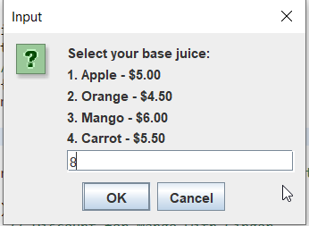

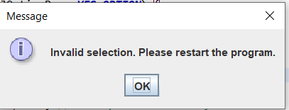

**Scenario 2:**

